Group: C1.036

Sevillano Barea, Alejandro - alesevbar@alum.us.es Naredo Bernardos, Ignacio- ignnarber@alum.us.es

Escudero Aldana, David - davescald@alum.us.es

CHARTERING REPORT

Repository: https://github.com/C1-036/Acme-ANS-C2

May 30ht, 2025

Content Table

1. Executive Summary 2

2. Revision Table 3

3. Introduction 3

4. Contents 3

5. Conclusions 6

6. Bibliography 6

# 

# 1. Executive Summary

This report outlines the process of assembling the team, defining commitments, evaluating performance, and managing project milestones. It begins by explaining how team members were selected, focusing on key criteria such as teamwork, communication, and dedication. Each member's contact details are also provided.

The report includes a statement of commitment, reinforcing the team's shared responsibility and understanding of the project goals. To maintain efficiency, it specifies performance metrics, recognition and reward systems, disciplinary measures, and conditions under which a team member may be removed if necessary.

Lastly, the document is finalized with the date and signatures of all team members, signifying their collective agreement and dedication to the project's success.

# 2. Revision Table

|  |  |  |
| --- | --- | --- |
| Revision number | Date | Description |
| 1 | 30/05/2025 | The report was changed to adapt it to the second try |
|  |  |  |

# 3. Introduction

This section offers a brief summary of the document’s contents. We begin by highlighting the main topics covered, including the recruitment process, team commitments, performance evaluation methods, management procedures for achieving our project milestone, and key performance indicators.

Our report starts by detailing how the team was assembled and the selection criteria used, emphasizing essential qualities such as teamwork, communication, and dedication. To ensure smooth coordination, we also provide contact information for each team member.

Next, we present our commitment statement, reaffirming our dedication to collective success and a shared understanding of the project’s objectives. We then outline our performance indicators, which will help assess efficiency, productivity, and engagement with stakeholders through customer or lecturer evaluations.

Additionally, we describe our reward system for high-performing members, disciplinary procedures for underperformance, and termination conditions for severe cases. Finally, the report concludes with the date and signatures of all team members, signifying their mutual agreement and commitment to the project’s success.

By following this structured approach, we aim to establish a clear framework for efficient project management while promoting transparency and accountability within our team.

# 4. Contents

**Summary of Recruitment:**

For this first milestone, the manager voluntarily assumed the role and took responsibility for organizing the work environment, including setting up the repository to enhance collaboration. Through meetings, the manager brought the team together and coordinated efforts to accomplish the goals of this initial deliverable.

**Contact Information:**



Sevillano Barea, Alejandro

Email: [alesevbar@alum.us.es](mailto:alesevbar@alum.us.es)

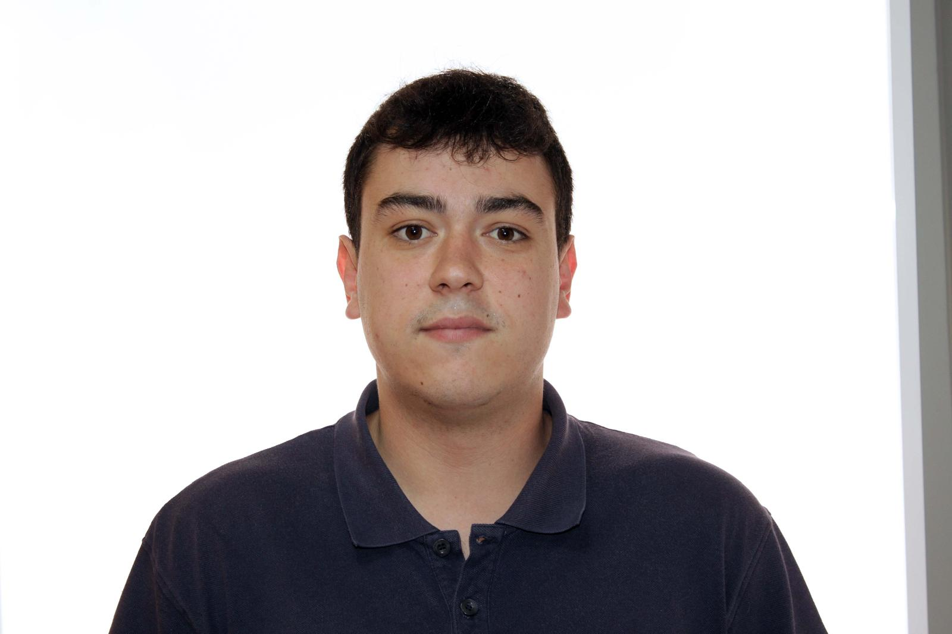

Naredo Bernardos, Ignacio

Email: [ignnarber@alum.us.es](mailto:ignnarber@alum.us.es)



Escudero Aldana, David

Email: [davescald@alum.us.es](mailto:davescald@alum.us.es)

**Commitment Statement:**

The main objective of the team is to pass the Design and Testing 2 course with a grade of 5. Once this objective is achieved, we will focus on obtaining the best possible grade, promoting fluid communication between members and valuing individual effort, essential for the success of a team project.

**Performance Indicators:**

A key performance indicator for our project will be the difference between the expected objective and the objective achieved. This metric will provide insight into the efficiency and productivity of our team members.

For each deliverable, the expected objective will be the fulfillment of the previously established mandatory requirements.

Performing Well:

The achieved objective is equal to or exceeds the expected objective.

Performing Bad:

There is a significant gap between the expected objective and the achieved objective.

These definitions will serve as clear benchmarks for evaluating the performance of our workgroup members and guiding improvement efforts as needed.

**Reward System:**

Outstanding team members will receive public recognition and have the opportunity to take on leadership roles in future project milestones.

**Admonishment Procedure:**

Underperforming team members will receive formal warnings and have access to additional support and training opportunities to improve their performance.

**Termination Conditions:**

A team member may be dismissed after receiving the following warnings:

1st warning: Failure to attend any meetings for 2 weeks.

2nd warning: No commits on GitHub for 3 weeks.

3rd warning: Failure to attend any meetings for 4 weeks.

If all these warnings are met, they will be automatically dismissed from the project.

**Date and Signatures:**

This report is dated February 16, 2025. All team members are willing to sign the report to indicate their agreement and commitment to its content.

___________________________ Sevillano Barea, Alejandro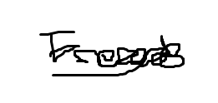

_________________Naredo Bernardos, Ignacio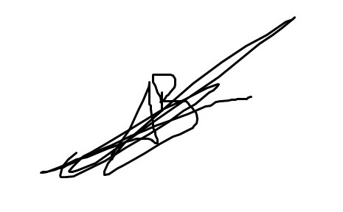

___________________________ Robles Borrego, Adrián 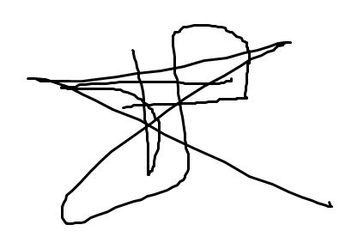

___________________________ Sabido González, Francisco Manuel 

___________________________ Escudero Aldana, David

# 5. Conclusions

This report provides a solid foundation for managing our project and developing efficient teamwork. We have clearly laid out the selection process, team commitments, performance metrics, and management procedures. Throughout the document, our commitment to communication and collaboration is reflected.

The performance indicators, incentive system, and disciplinary measures outlined encourage accountability and continued growth. By signing this document, we reaffirm our collective commitment. With this structure in place, we have a solid foundation for success, promoting both excellence and teamwork.

# 6. Bibliography

Intentionally blank.